Муниципальное бюджетное общеобразовательное учреждение
«Гимназия №3 имени Б.В. Шапошникова»

Творческий проект по английскому языку на тему:
«Holidays in Britan»

Выполнила: ученик 6а класса
Антохин Тимофей
Руководитель:
учитель английского языка
Рыбакина Анастасия Сергеевна

Содержание:
ВВЕДЕНИЕ…………………………………………………………………………………..3
ГЛАВА 1……………………………………………………………………………………...4
1.1. Valentine’s Day …………….……………………………………………………………4
1.1.1. The history of the Valentine’s day ………………………………………................….4
1.1.2. Symbols …………………………………………………………………………….….5
1.2. St. Patrick’s day ………………………………………………………………….……...6
1.2.1. The history of the St. Patrick’s day…………………………………………...………..6
1.2.2. The shamrock is a St. Patrick’s Day Symbol …………………………………...……..6
1.2.3. How is St. Patrick’s Day celebrated in the UK……………………………………...…6
1.3. Guy Fawkes Night ………………………………………………………….…………....7
1.3.1. The Real Story of Bonfire Night……………………………………………………….7
1.3.2. How is Guy Fawkes day celebrated …………………………………………………...8
1.4. Easter ………………………………………………………..………………………...…9
1.4.1. The origin of Easter…………………………………………………………………….9
1.4.2. Symbols of Easter……………………………………………………………….…….10
1.4.3. British Easter Traditions……………………………………………………………....11
ГЛАВА 2…………………………………………………………………………………….12
2.1.Valentine’s Day Quiz : True or False……………………………………………...….…12
2.2 St. Patrick’s Day Quiz : True or False ………………………………………….............12
2.3 Guy Fawkes Night Quiz : True or False……………………………………………...….12
2.4 Easter Crossword Quiz……………………………………………………………….…13
ЗАКЛЮЧЕНИЕ…………………………………………………………………………….14
СПИСОК ИСПОЛЬЗОВАННОЙ ЛИТЕРАТУРЫ…………………………………….....15

ВВЕДЕНИЕ
В нашей работе речь пойдёт о английских праздниках как существенной части английского национального характера. Я не раз слышал о том, что английские праздники своеобразны, что они является национальным достоянием англичан. Поэтому я решил провести исследовательскую работу и разобраться в чем заключаются их особенности.
Данная работа посвящена особенностям английских, как способа национальной идентификации.
Актуальность выбранной темы связана с необходимостью знания английского языка в современном мире и поиском эффективных способов его изучения. Английские праздники помогают глубже проникнуть в культуру англичан, поскольку в праздниках находят выражение её основные ценности и приоритеты, а это, в свою очередь, позволяет сформировать навыки и умения аналитического подхода к изучению зарубежной культуры в сопоставлении с культурой своей страны. Ведь восприятие иноязычной культуры всегда происходит через призму собственной.
Цель работы – анализ особенностей английских праздников как неотъемлемого специфического явления английской культуры.
Задачи работы:
1) изучить теоретический материал, посвящённый праздникам как культурной составляющей;
2) изучить специфические особенности английских праздников и его классификацию;
3) проанализировать трудности понимания английских праздников, а так же как их можно использовать в изучении языка и понимании культуры.
Работа состоит из введения, двух глав, заключения, списка использованной литературы и приложения.

ГЛАВА 1
  - Valentine’s Day
    - The history of the Valentine’s day
Every year, millions of kids give cards and candy to their classmates or secret crush. But why? Who invented Valentine's Day, and when did it start?
As you probably know, Valentine's Day, also known as Saint Valentine's Day, is a holiday held every year on February 14th to celebrate our loved ones, give them cards, candy, and other gifts to show them how we feel.
Who is Saint Valentine? And why was this lovely holiday named after him?
It's hard to say. For starters, there are several different saints
named Valentine. Experts can't say for sure which one is the man behind the holiday, but some believe it's named after Saint Valentine of Rome, who died in 269 A.D. after defying the Emperor.
Claudius II decided that single men make better soldiers than guys with wives and families, so he outlawed marriage for young men of fighting age. Saint Valentine defied the Emperor's orders and continued performing marriage ceremonies for young, love-struck couples in secret until he was discovered and put to death.
Okay, so the history of how the holiday got its name is murky to say the least, but what about its date?
Why does Valentine's Day fall on February 14th? Most experts believe Valentine's Day was picked to keep the tradition of an old Roman festival called Lupercalia.
It was a day-long holiday dedicated to love and fertility held on the 15th of February each year. As Christianity spread across the Roman Empire, Lupercalia was outlawed and replaced with a church-approved version held the day before known as Saint Valentine's Day that took its place.
By the Middle Ages, lovers began giving valentine's to each other.
The oldest-known valentine was written in 1415 by Charles, Duke of Orleans to his wife while he was locked up in the Tower of London after being captured in battle.
A woman named Esther Howland, known today as the mother of the American valentine, invented the first mass-produced version, which was decorated with lace, colored paper, ribbons, and other things we're still using to make them.
Today, almost 150 million Valentine's Day cards are sent every year, and that number is only growing.
So this year, if you've got a special someone on your mind, do what people have done for thousands of years.

    - Symbols

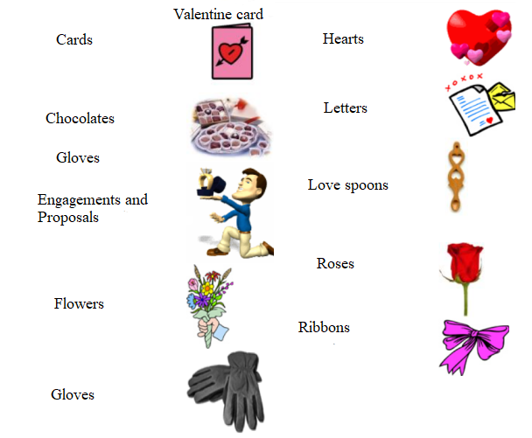

1.2. St. Patrick’s day
1.2.1. The history of the St. Patrick’s day

Saint Patrick was born in Britain, his family was very rich.
When St. Patrick was 16 years old, something terrible happened. The group of pirates attacked St. Patrick’s home. Then they kidnapped the young man and took him to Ireland.The pirates sold St. Patrick as a slave.
He worked as a shepherd.Being far away from his family made St. Patrick feel sad and lonely. But St. Patrick prayed every day.His faith grew stronger and stronger. One day, St. Patrick heard a voice telling him to run away.So, St.Patrick listen to the voice.He escaped and vent to France.In France St. Patrick became a priest. When St. Patrick was about sixty years old he returned to Ireland. He wanted to tell the Irish about his faith.Almost everybody loved Patrick.

1.2.2. The shamrock is a St. Patrick’s Day Symbol

He carried the shamrock with him. A shamrock is a three-leaf clover. St. Patrick used a shamrock to teach people about God.

1.2.3. How is St. Patrick’s Day celebrated in the UK

Ireland’s long-standing affiliation with the shamrock is said to have originated from the teachings of Saint Patrick, who used its three leaves as a metaphor for the holy trinity – the father, son and holy spirit. To celebrate, it has become customary to “drown the shamrock” on St Patrick’s Day. This sees revellers bid the night farewell by taking their national plant and dropping it into their final drink.

1.3. Guy Fawkes Night
1.3.1. The Real Story of Bonfire Night

The Gunpowder Plot was one of the most famous attempts to kill a king in British history. A group of men, including one named Guy Fawkes, planned to blow up the Houses of Parliament. They were caught before they could carry out the plot, however. Every year on the anniversary of the plot, people in the United Kingdom celebrate the fact that the plot failed. The celebrations include bonfires and fireworks.
The men who planned the Gunpowder Plot were Roman Catholics who were unhappy with the way they were being treated. James I, the first of the Stuart kings of England, came to the throne in 1603 the time, there were many conflicts between Protestants and Roman Catholics. James succeeded Elizabeth I, a Protestant, who did not allow Catholics to practice their religion as they wished. Roman Catholics in England expected James to treat them well because his mother was a Catholic. Instead, he ordered all Catholic priests to leave England. The men were furious that their hopes of religious tolerance had been dashed.
The men plotted to kill not only the king but also the queen, their son Prince Charles, and every member of the government during the state opening of Parliament on November 5, 1605. The leader of the group was a man called Robert Catesby. Cellars beneath the Houses of Parliament were rented out as storage spaces to people such as coal merchants, and the gang leased one of these cellars. They gradually moved in 36 barrels of gunpowder and hid them there. It was enough gunpowder to blow up hundreds of people.
The night before the opening of Parliament, soldiers caught Guy Fawkes in the cellar. They arrested him and took him to the Tower of London. After three days of torture, Fawkes told his captors the names of his fellow plotters. They were all arrested for treason—plotting against the king and the country—and were imprisoned in the Tower.
On January 30–31, 1606, the whole gang was executed as hundreds of people watched. Afterward their heads were cut off and displayed on poles throughout London, to warn others what would happen to them if they plotted against the king. In celebration of his survival, James ordered that the people of England should have a great bonfire on the night of November 5, which is now known as Guy Fawkes Day.

1.3.2. How is Guy Fawkes day celebrated

Today Guy Fawkes Day is celebrated in the United Kingdom, and in a number of countries that were formerly part of the British Empire, with parades, fireworks, bonfires, and food. Straw effigies of Fawkes are tossed on the bonfire, as are—in more recent years in some places—those of contemporary political figures.

1.4. Easter
1.4.1. The origin of Easter

Easter is the holiest day of the year for Christians. It celebrates their belief in the resurrection, or the rising from the dead, of Jesus Christ. Jesus was the founder of the religion of Christianity. Easter is always observed on a Sunday in the spring, but its date varies. It can fall on any Sunday between March 22 and April 25.
The name Easter may come from Eostre, an Anglo-Saxon goddess. In ancient times, an annual spring festival was held in her honor.
In many churches Easter follows a season of prayer and fasting called Lent. This is observed in memory of the 40 days Jesus is said to have fasted, or gone without food, in the desert. Lent begins with Ash Wednesday. This day gets its name from the practice of putting ashes on the foreheads of the faithful as a symbol of the season.
The week before Easter Sunday is known as Holy Week. During this week, Christians remember the events they believe took place at the time of Jesus’ death. Palm Sunday recalls the entrance of Jesus into Jerusalem shortly before his death. Holy Thursday marks the Last Supper of Jesus with his disciples, or followers. Good Friday remembers the crucifixion, when Jesus was killed by being nailed to a cross. Christians believe that Jesus was resurrected on the third day after his death. Easter is therefore a celebration of new life.
On Easter, Christians attend special church services. A number of popular folk customs are also associated with Easter. These have to do with rabbits and colored eggs, which are ancient symbols of new life. In some countries children color eggs and then the eggs are hidden for them to find. According to tradition the Easter Bunny also leaves eggs and candy for children on Easter morning.

1.4.2. Symbols of Easter
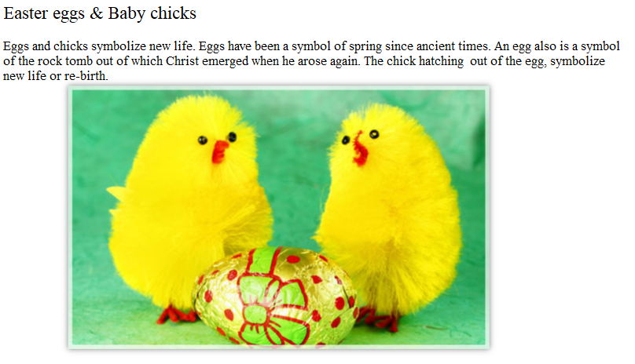
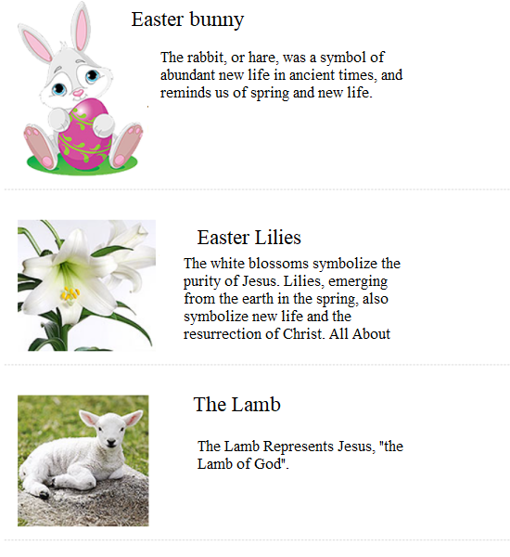

1.4.3. British Easter Traditions

On Easter day some countries have egg-rolling competitions. The egg that rolls the farthest wins. But the most popular Easter game is the Easter egg hunt. Children believe the Easter Bunny brings the eggs during the night. On Easter morinig the children look for the eggs. Sometimes there is a prise for the child who finds the most eggs. Everyone has a good time. Easter is a fun time for the whole family. It is a time to celebrate life.

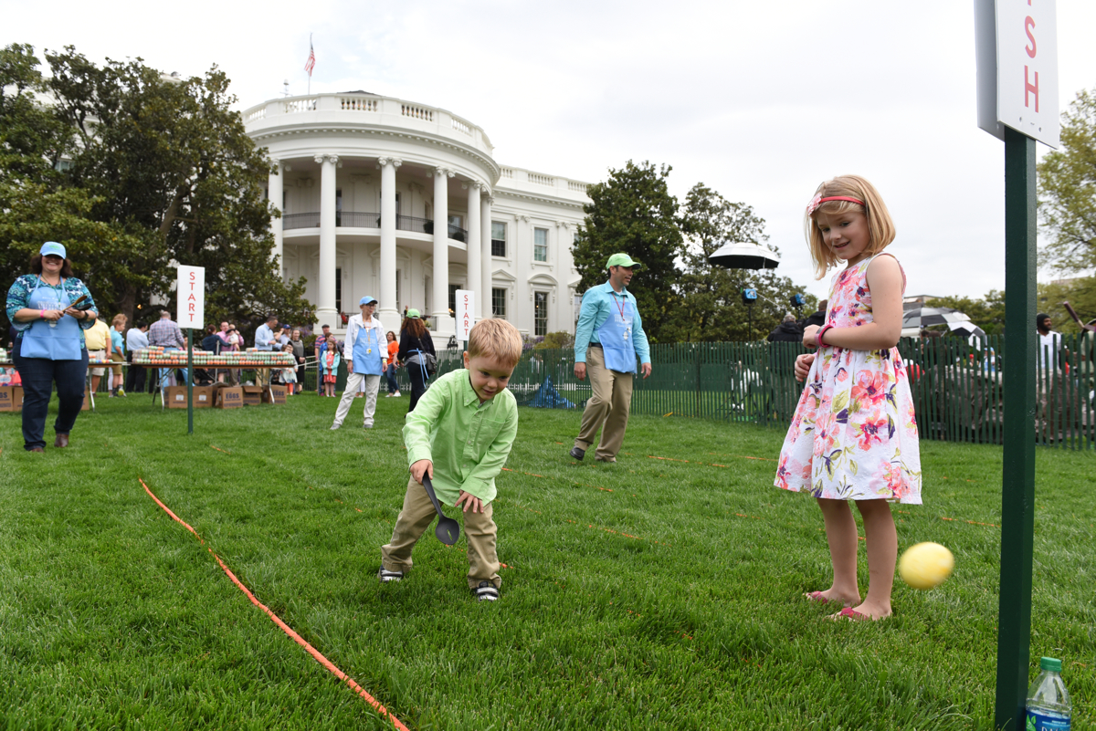

ГЛАВА 2
2.1.Valentine’s Day Quiz : True or False
- Valentine was from England
- Valentine treasured the emperor’s orders and stopped holding wedding ceremonies for young lovers.
- The date of Valentine’s Day came from the holiday Lupercalia
- Valentine’s day celebrate on 15th of February
- The emperor’s name was Cladius II

2.2 St. Patrick’s Day Quiz : True or False

- St Patrick was born in Britain, and his family was very poor.
- The pirates sold St. Patrick as a slave
- St. Patrick used a shamrock to teach people about God.
- Almost everybody hated Patrick.
- St. Patrick prayed every day.

2.3 Guy Fawkes Night Quiz : True or False

- James the first was good to Catholics
- Planned to detonate 54 barrels with gunpowder
- The exploration planned on 5 of November, 1605
- The exploration named Gunpowder Plot
- Today Guy Fawkes Day is celebrated in the United Kingdom

2.4 Easter Crossword Quiz

- When is the Valentine’s day celebrated
- Why did Guy Fawkes want to make exploration
- What do eggs symbolise in Easter
- Where is the Guy Fawkes Day celebrated
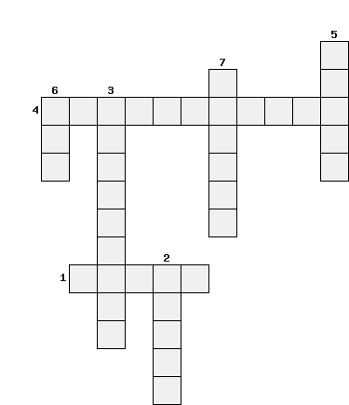
- What do Easter eggs look like

- The main symbol of Valentine’s day
- The main flowers of Valentine’s day
- The building Guy Fawkes wanted to blow up
- The main event on the 5th of November in 1605 year
- The main animal of Easter
- The main thing of Easter
- The holiday with eggs and bunnies

ЗАКЛЮЧЕНИЕ
Тема "Holidays in Britain" позволила мне узнать о различных праздниках и традициях, которые существуют в Великобритании. Я изучил множество фактов, исторических связей, культурных особенностей, и, что немаловажно, я понял, насколько эти праздники для британцев важны.

Мне кажется, что Великобритания - это прекрасная страна, насыщенная традициями и праздниками. Благодаря этому экзамену, я не только узнал о самых популярных и известных праздниках, но и понял, насколько важно сохранять культурное наследие и традиции своей страны. Поэтому заключение моего творческого экзамена по теме "Holidays in Britain" - это понимание того, что традиции и праздники Великобритании - это нечто более, чем просто обычаи, это ключевые элементы культуры и истории этой страны.

СПИСОК ИСПОЛЬЗОВАННОЙ ЛИТЕРАТУРЫ
1. https://www.youtube.com/watch?v=WXp3267uzMg
2. https://economictimes.indiatimes.com/news/international/us/what-is-4th-of-july-in-the-united-states-history-and-how-it-is-celebrated/articleshow/92658716.cms
3. https://kids.britannica.com/kids/article/Independence-Day/400595
4. https://www.parents.com/holiday/july-4th/19-fun-4th-of-july-facts-for-kids-to-explain-the-history-of-the-holiday/
5. https://www.kidsgen.com/events/easter/easter_symbols.htm
6.https://en.wikipedia.org/wiki/Egg_rolling#/media/File:The_White_House_Easter_Egg_Roll_2017_JNB_1779_(33792291300).jpg

